Application of Pneumatic and Hydraulic Systems in Vitrox MVSS

# Introduction

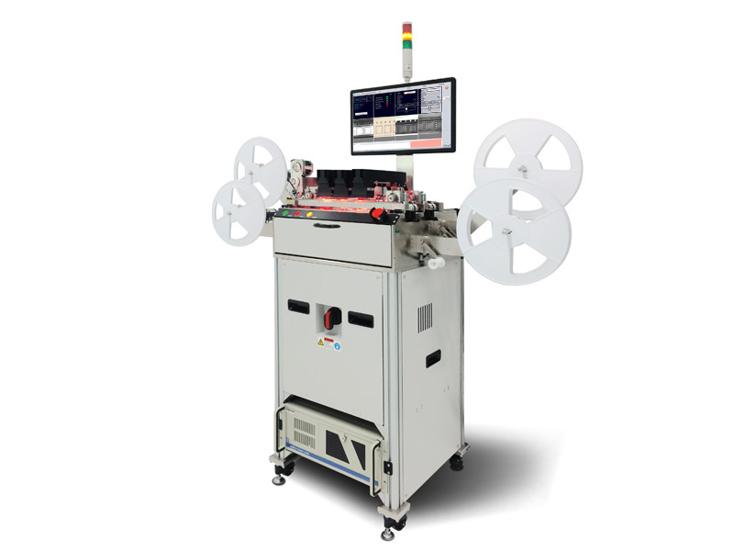

Figure: VR20 Li Post Seal Vision Handler

VR20 is Vitrox MVSS department main product, which is a post seal vision handler which is able to inspect different SMT IC types. The IC types include Ball Grid Array ( BGA), quad flat package (QFP), quad flat no-leads (QFN), Thin Shrink Small Outline Package (TSSOP), Chip- Scale Package (CSP) Mini Small Outline Package (MSOP) and Small Outline IC Package ( SOP). The IC is already placed in a strip of tape before it is reeled into the machine by an operator.

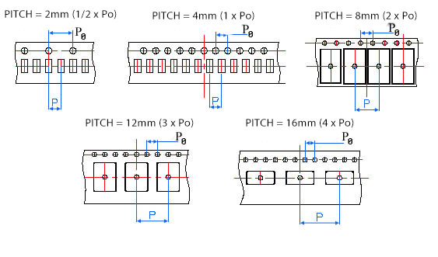

Figure: Different types of pitch sizes

The machine is able to cater for different kinds of tape standards. The tapes come in different pitch widths, such as 4mm, 8mm, 12mm and 16mm. The tapes also come with different thickness and width. The MVSS team will configure the machine to satisfy different specifications of IC packages required by the customer by undergoing thorough visibility testing to ensure the inspection works flawlessly on different IC packages.

It is able to detect various defects in tape seal, marking on the IC, Package, Lead of IC and bottom carrier tape. The various types of defects the system is able to detect is shown below.

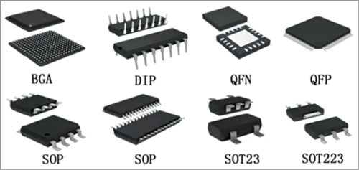

Figure : Different types of IC packages

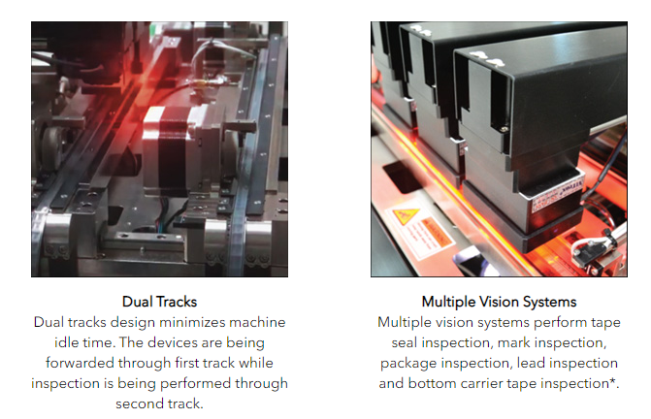

Figure : Features Pt.1 of VR20 i

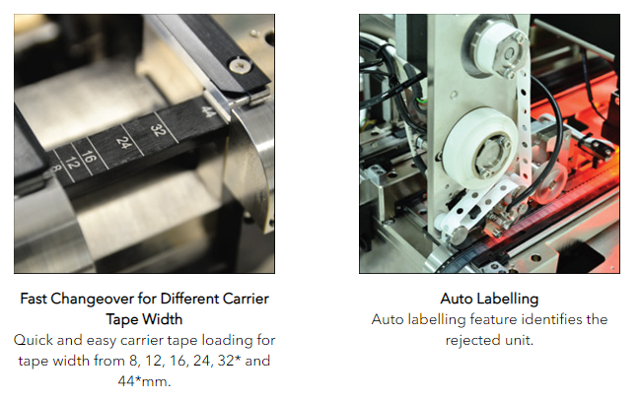

Figure : Features Pt.2 of VR20 i

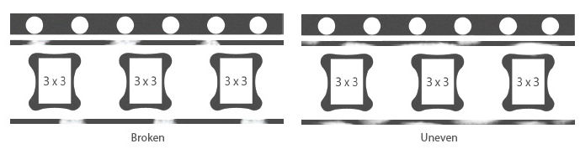

Figure : Tape Inspection by VR20 i

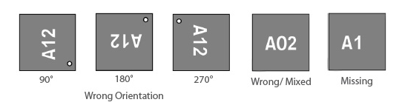

Figure : Marking Inspection by VR20 i

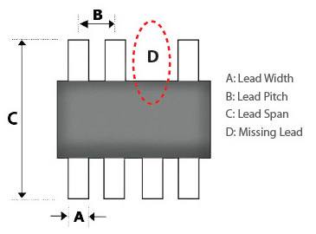

Figure : Lead Inspection by VR20 i

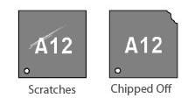

Figure : Package Inspection by VR20 i

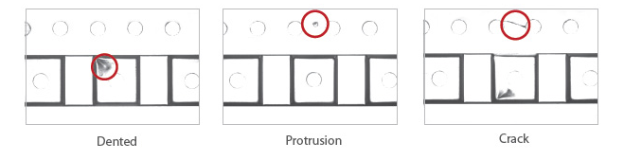

Figure : Tape Inspection by VR20 i

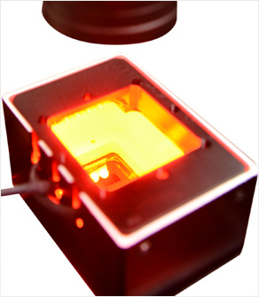

Figure : Tape Seal inspection setup

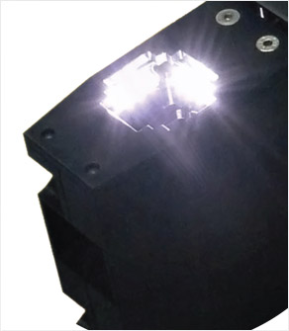

Figure : Bottom carrier tape inspection

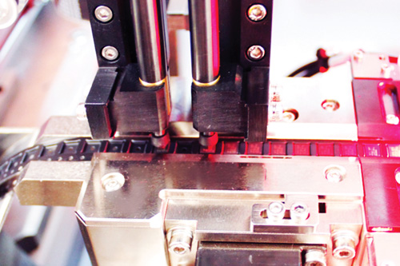

Figure: Close up of tape inspection

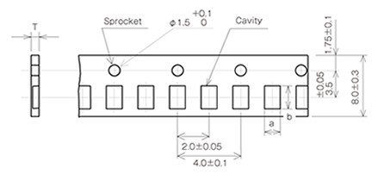

# VR20i - How it works

MVSS is currently working on a second iteration of VR20i which is VR20i G2. It has a few key improvements over VR20i G1.



## VR20i G1

In general, VR20i completes a two-way back and forth process. The tape will be rolled from the left arm to the right arm (rewinding), then it will be rolled back from the right arm to the left arm (inspection). Inspection only happens on the later process. The original VR20i requires two operators. The rolled tape is first place in the left arm. The first operator has to place the tape into the track. Once the tape is placed into the track, the sensor will detect the presence of the tape. There will be a sensor on top of the track to detect the first sprocket (shown above). The sprocket will be used for indexing, to determine which IC package is being visually inspected. Then, the motor will be triggered to move the tape along the track. The tape will go through the track once to rewind at the other arm (right arm). The second operator has to manually wind the tape at the right arm. Then the process is reversed. The tape is pushed back into the track by the second operator. Inspection occurs when the tape goes from right arm to left arm via the track. This two way process, rewinding and inspection is needed so that the IC package is rolled back into the same initial position. Double track allows one track to be inspected while another track is rewinding, which speeds up the process. VR20i G1 also has 4 different vision systems in it, with different camera and lighting setup to inspect marking, tape seal, bottom tape and lead of the SMT IC.

## VR20i G2

For the 2nd iteration of VR20i, a new design is built based on the original VR20i. The main improvements are tension control for the tape reels in the left and right arm to prevent tape from snapping, and there is an auto rewind function in the right arm, which reduces the number of operators from 2 to 1. The rest works the same as the 1st iteration. The VR20i G2 is still in the testing phase and will have a target release in the middle of 2021.

# Pneumatic and Hydraulic Systems in MVSS

Pneumatic and hydraulic systems both are applications of fluid power. Each uses a pump as an actuator, is operated by valves, and transmits mechanical energy by fluids. The most significant distinction between the two kinds of structures is the medium and applications used. Hydraulics uses comparatively incompressible liquid media such as hydraulic or mineral oil, ethylene glycol, water, or high temperature fire-resistant fluids, whereas pneumatics uses a readily compressible gas such as air or other suitable pure gas. Since their implementations are specialized, neither form of device is more common than the other (Rapchak, 2020).

## Pneumatic

Pneumatics is a branch of engineering that uses pressurized gas or air to control mechanical motion using fluid mechanics and pressure concepts. Pneumatics has evolved from small portable instruments to large machines that perform a variety of tasks. Compressed air or inert gases are typically used to operate pneumatic devices. A gas compressor, transfer lines, air tanks, hoses, regular valves, and gas are among the integrated components of the system (atmosphere). The compressor provides compressed air, which is delivered by a series of hoses (Rapchak, 2020).

Manual or automatic solenoid valves control air pressure, while the pneumatic cylinder transforms compressed gas energy into mechanical energy. Cylinders, air turbines, and other pneumatic machines are operated by a centrally positioned and electrically powered compressor. A basic ON/OFF switch or valve controls pneumatic systems.

Most industrial pneumatic applications use pressure of 550 to 690 kPa. The compressed air is stored in receiver tanks before it is transmitted for use.

Advantages of pneumatic systems are lower cost, flexibility and better safety levels compared to hydraulic systems. They have no risk of contamination unlike hydraulic systems. Clogging and maintenance is less of an issue and they are easy to install and very portable.

Disadvantages of pneumatic systems are relatively lower force created, movement can be inconsistent and unstable due to air pressure fluctuations. Heat produced by compressing air also increases energy lost, and in the process creates a lot of noise, which may harm the operator’s hearing.

## Hydraulics

Using pressurized liquids, hydraulics is used to generate, control, and transmit power. Hydraulic systems, like pneumatic systems, require a pump and use valves to adjust the power and velocity of the actuators. Hydraulic systems in industry range from 1000 to 5000 psi, with advanced applications requiring more than 10,000 psi (Rapchak, 2020).

Unlike pneumatic systems, hydraulic systems are often big and complicated. Since a container is needed to store fluid that runs through the system, the system needs more space. Since the system is wider, more resistance is needed, making it more costly than pneumatic systems. Hydraulic systems can lift and transport bigger materials due to their total scale and the incompressibility of gasoline. Since oil is viscous and takes more energy to pump across tubing, hydraulic systems are slower .

Advantages of Hydraulics are it is more capable of moving heavier loads and providing higher forces due to the incompressibility of liquids. Hydraulic systems also include lubrication, cooling and power transmission. Small scale hydraulic actuators generate a lot higher force.

Disadvantages of hydraulics is that it is usually larger and more complicated systems. Hydraulic oil, for example, is viscous and takes more energy to transfer. A tank is also needed to store the oil so that the machine can draw from it when the oil supply is limited. Since electricity must be integrated into the unit, the initial costs are greater than for pneumatic devices.

Any leakage in a hydraulic system will lead to major issues. Owing to the high probability of hydraulic oil leakage from defective seals, valves, or burst hoses, this device is not suitable for food applications. At each location, proper plumbing practices, preventive and routine repairs, and getting the right materials on hand are needed to mitigate possible leakage and rapidly resolve any problems. Finally, pneumatic machines are better designed for low-scale manufacturing and mechanical operations, whereas hydraulic systems are best suited for applications requiring greater power and heavy lifting (Rapchak, 2020).

VR20i is a small sized machine which inspects the SMT IC packages on the tapes. Therefore, pneumatic systems are used for VR20i.

## Tape Clamper - Track

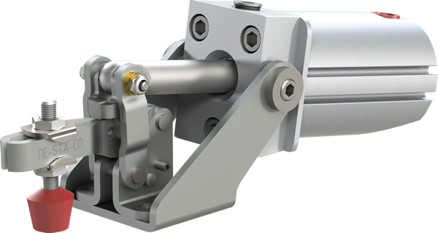

Figure: Example of Pneumatic clamp

Air-actuated cylinders to operate the clamping action. Very ideal for quick clamping in repetitive production operations, which is used for holding the tape in place when vision inspection is undergoing on the track. When inspection is done, the clamp is released, and the tape continues moving. Other than inspecting, the clamp also holds the tape in place when labelling which package has defects.

## Auto Light Source Conversion - Vision System

Flexibility as it caters to different types of package inspections, namely MEMs devices, conventional black mold packages and WLCSP packages which are able to support high mix low volume of the manufacturing requirements nowadays. Different packages can be optimized with the multiple groups of light sources and the individual lighting to maximize the inspection capability (Vitrox, 2020).

This automated light source conversion method operates in a fraction of a second, resulting in a major improvement in output quality. With the aid of our in-house light source controller, the auto light source conversion system auto-triggers the movement of the light source to illuminate the different IC packages properly. Human error caused by manual labor on the computer is both prevented and eliminated by automation. The standard of the final goods would be much better than with manual testing (Vitrox, 2020).

## Rotary Union - Right Arm

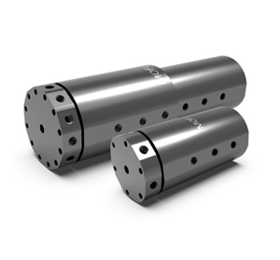

Figure: Rotary Union

Rotary unions or joints seal and transfer fluid like water, air, coolant, steam or other forms of media from static to 360° continuous rotating parts. For the rotary union in the right arm of the VR20i G2, it is used to transmit pneumatic power.

A spring-loaded seal is used in traditional rotary joints to prevent the oil or gas medium from dispersing into the atmosphere. The rotary joint uses a spring to maintain the original internal seating, and once in use, the rotary joint is pressure-sealed. The spring force is used to create the seal in low-pressure or vacuum applications. Traditional rotary joints are either internally protected by an internal carbon guide or externally supported by rods or a mounting bracket (KADANT, n.d.).

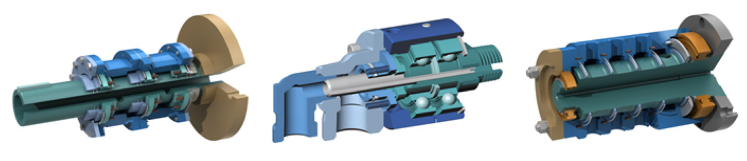

Figure: Internal structure of a rotary union

## Tape Guider - Right Arm

Vitrox VR20i G1 and G2 SMT inspection machines have to be flexible in inspecting different kinds of tape standards. Therefore, it is important that the tape guider in the right arm is able to change different widths based on the tape. This ensures that the tape is correctly rolled into the track and back into the roller. The width of the tape guider is not adjusted manually but through clampers controlled by pneumatic pistons.



Figure: Tape Guider

Reference

1. Rapchak, L. (2020, August 29). Pneumatics vs hydraulics: What is the difference: Nex flow air products. Retrieved April 01, 2021, from <https://www.nexflow.com/blog/difference-between-pneumatics-and-hydraulics/#:~:text=Pneumatics%20use%20an%20easily%20compressible,high%20temperature%20fire%2Dresistant%20fluids>.
2. Vitrox. (n.d.). VR20i G2 - an auto light source conversion feature is going to be launched!. Retrieved April 02, 2021, from <https://vitrox.com/blog-technologies/post/2020/post-dec-auto-light-source-conversion-feature-launched.html>
3. KADANT. (n.d.). Retrieved April 02, 2021, from https://www.kadant.com/en/blog/maintenance/what-are-rotary-joints-rotary-unions